**CAP:454 LINUX & SHELL SCRIPTING LABORATOY**

**NAME: - EKHLAKH AHMAD**

**ROLL NO.: - RD2215B67**

**REG NO.: - 12209166**

**GROUP: - 2**

1. **Config the statis internet connecting and create a file where you have to write all the steps of implementation along with screenshots.**

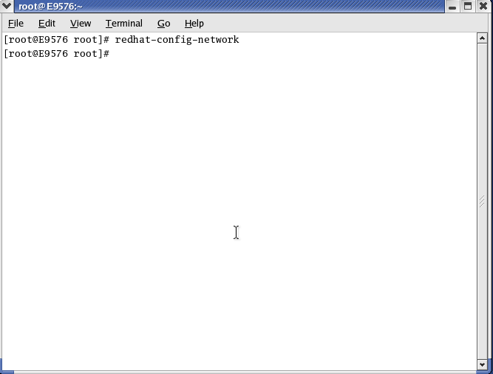**Process: -**

* Open terminal.
* Type “redhat-config-network
* Then press enter key.
* 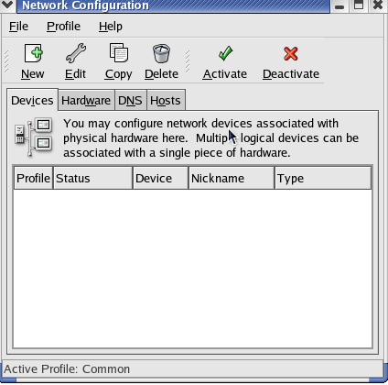Then a dialog box open.

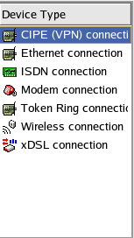

* Click on New option.
* Select Ethernet connection.
* Click on Forward.
* Selected “AMD PCnet32(eth0O).
* Click on Forward.
* Then a dialog box open.
* 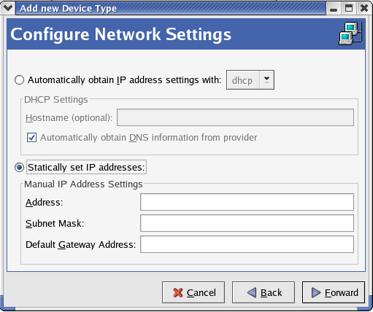select “Statically set IP address.

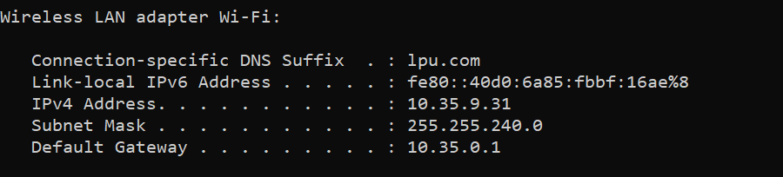

* Open window cmd comman promt.
* Type IPCONFIG.
* Then see IPADDRESS.
* 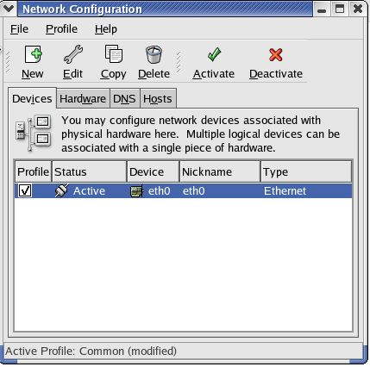Type IP Address.
* Type Subnet Mark.
* Type Default Gateway.
* Click on Forward.
* Click on apply.
* Click on Activate.
* Click on yes.
* Click on ok.
* Again click on ok.
* Net connect successfully.

1. 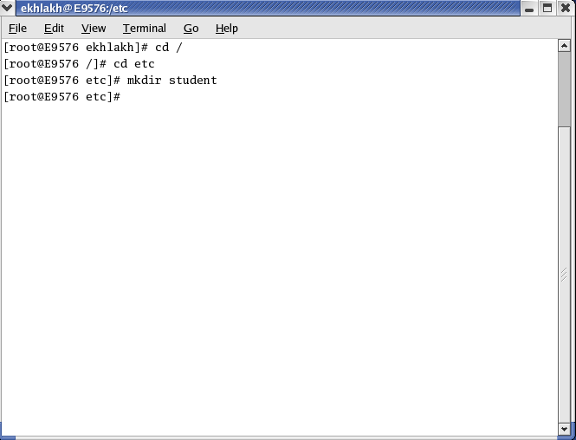**Create a directory with name student inside/etc. create two more directory with name hobbies and academy. Create one text file in hobbies directory using cat and another text file in academy using touch. At the end delete all directory & files.**

**Process: -**

* Open terminal.
* Type su root.
* Then password.
* Type cd etc
* Type mkdir student.
* Then press Enter key.

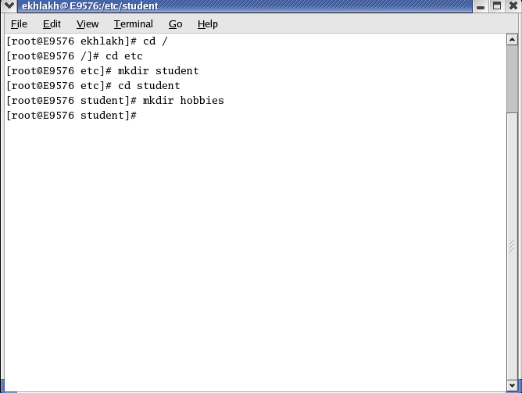

* Type cd Student.
* Type mkdir hobbies.

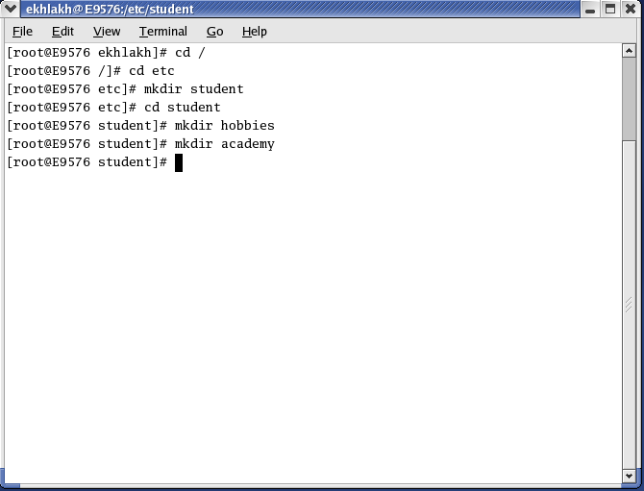

* Again type mkdir academy.

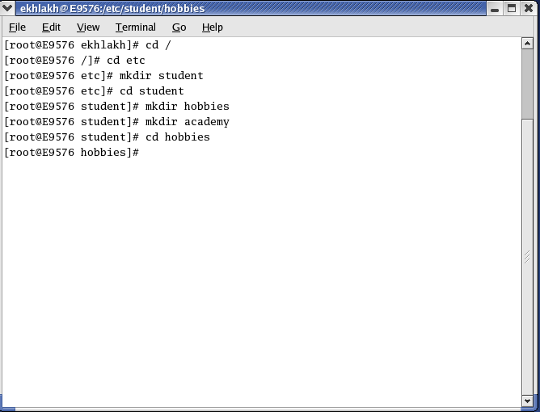

* Type cd hobbies.

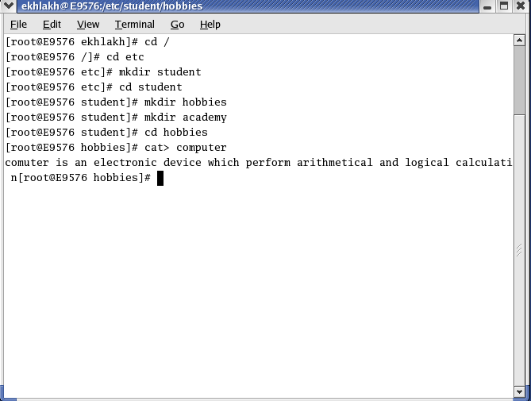

* Again type cat> computer
* And type your message.
* Press “Ctrl + D” key. (for save document).

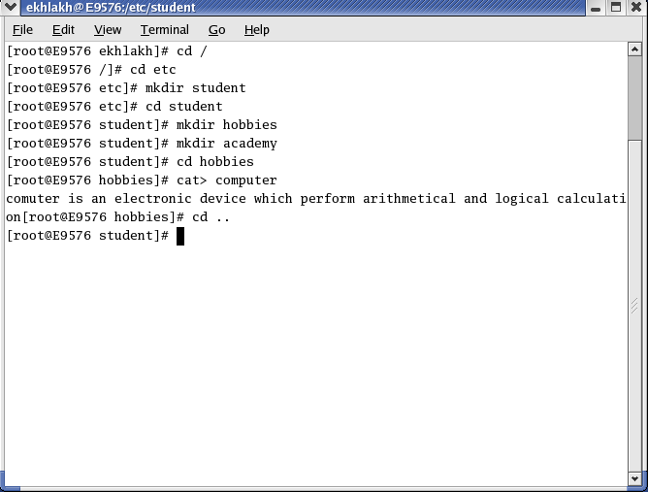

* Click on cd ..
* Press enter key.

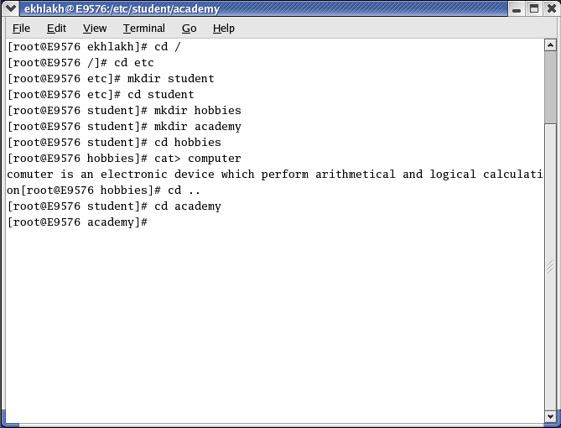

* Type cd academy

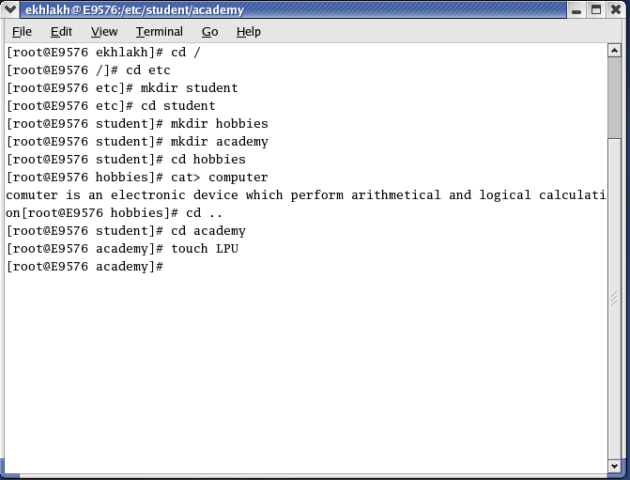

* Type touch LPU (LPU is file name).
* Click on Enter key.
* Type cd .. Press enter key. (for One step back).

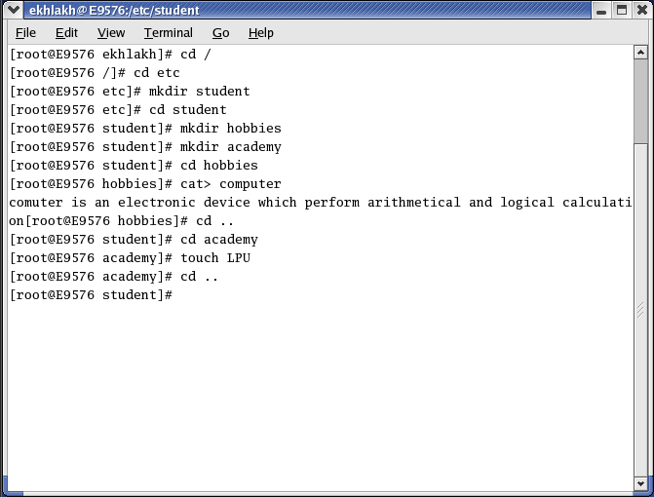

* Again type cd .. enter key. (for one step again back).

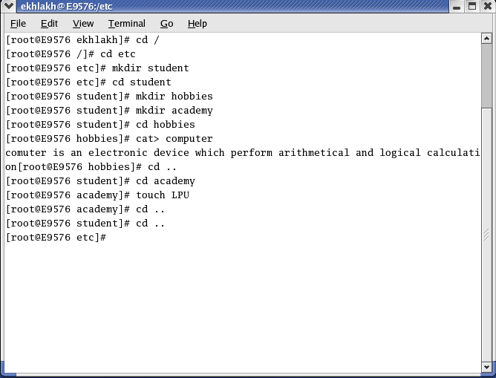

* Type rm -rf Student. (for delete all file and directory).

